Student Information
What is required to pass this unit of the Certificate III in Pest Management
The on-line theory component of the Certificate III in Pest Management includes
- Tutorials to read
- Flash activities to complete as part of assessment (you will need access to abode flash player)
- Industry information PDF’s
- Simulated pest management site maps examples
- Videos to watch
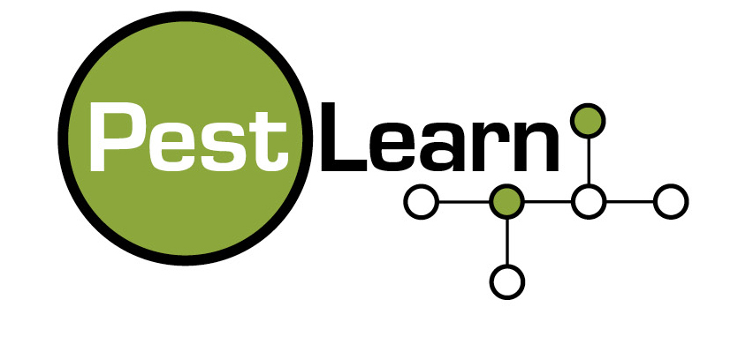
- Example report writers and pre agreement documents

Assessment Criteria
The assessment component to completing units in Certificate III in Pest Management include
On- line assessment - students must complete all required on-line assessments which include
- true or false questions
- multiple choice questions
- short answer questions
- missing word questions
- essay questions
- matching questions
- missing word questions
- drag and drop questions

Projects and Assignments
Each unit may contain a combination of
- written assignments
- in the field projects including competency record booklets
- in the field projects including on-line forms
- identification forms
- in the field report writer assessments

Video assessments
In cluster one, two or three, each student will need to complete an on-site video of themselves completing the required job task for assessment.
This is a critical part of each students portfolio of evidence of competency.
The student must be able to perform their job task in the field.
The video will need to be downloaded then edited to conform with the instructions.
Once all of the required instructions are covered off the student places the video file into the drop box and shares the file with their assessor or trainer to access.
Alternatively, the student can send the video file on a USB stick to your trainers postal address.

